* [Retrieve the start times of members' bookings](https://pgexercises.com/questions/joins/simplejoin.html)

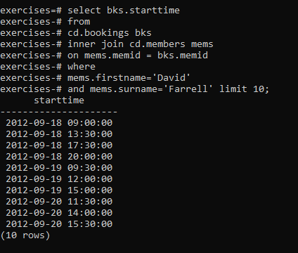

[Work out the start times of bookings for tennis courts](https://pgexercises.com/questions/joins/simplejoin2.html)

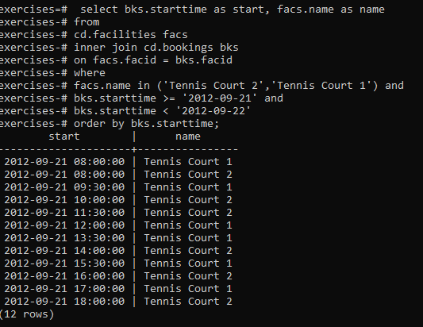

[Produce a list of all members who have recommended another member](https://pgexercises.com/questions/joins/self.html)

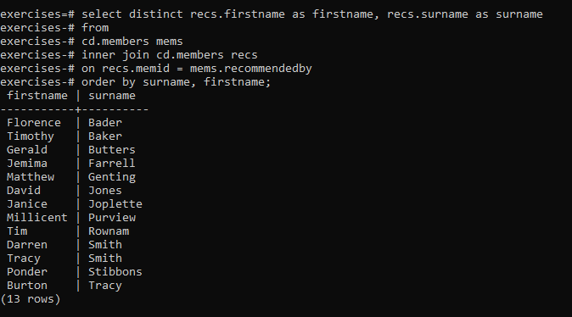

[Produce a list of all members, along with their recommender](https://pgexercises.com/questions/joins/self2.html)

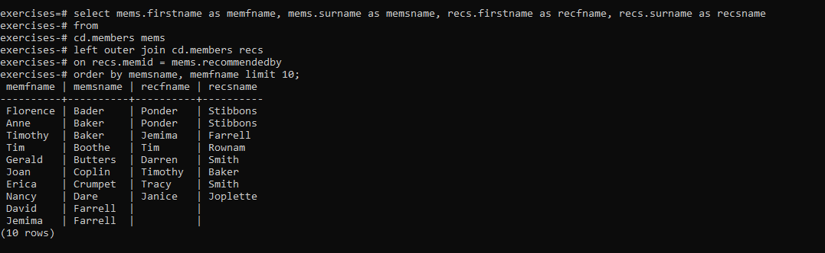

[Produce a list of all members who have used a tennis court](https://pgexercises.com/questions/joins/threejoin.html)

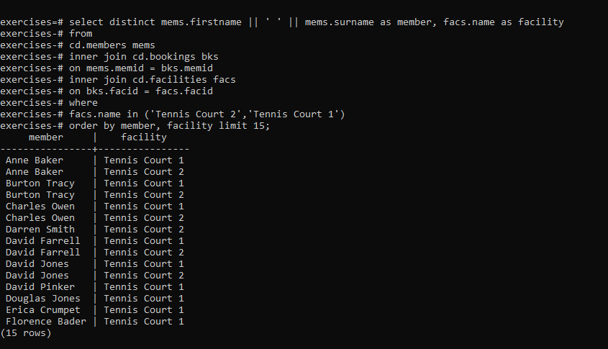

* [Produce a list of costly bookings](https://pgexercises.com/questions/joins/threejoin2.html)

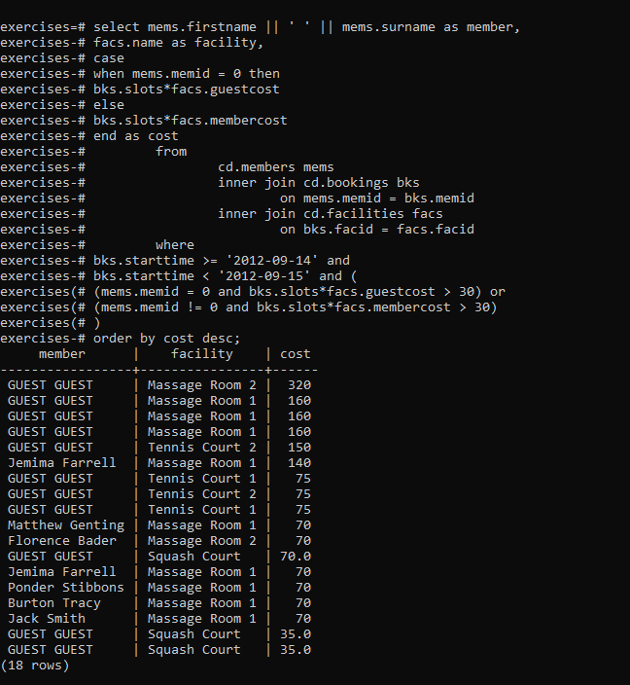

* [Produce a list of all members, along with their recommender, using no joins.](https://pgexercises.com/questions/joins/sub.html)

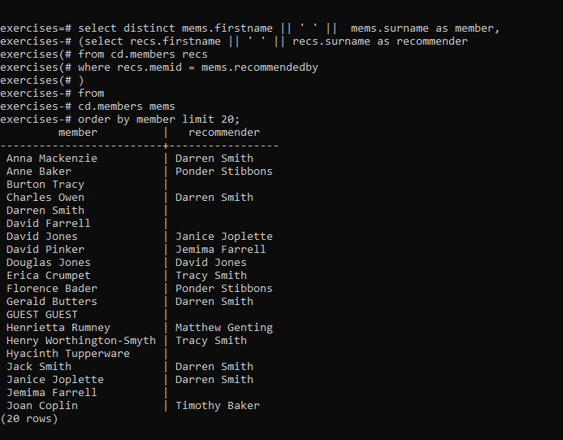

* [Produce a list of costly bookings, using a subquery](https://pgexercises.com/questions/joins/tjsub.html)

